From: Janet [mailto:Janet@fireskye.net]
Sent: Saturday, July 07, 2007 8:38 PM
To: 'parcarp@comcast.net'
Subject: Maury Cty Lookup
Hi Paulette,
I have a fascinating letter written by my great grandfather, and would love to pinpoint the location of the farm he mentions in this letter. The individual mentioned is Dr. Aaron White of Spring Hill. I will attach the
letter for your review. Any info about him would be great.
Thanks in advance for your time,
Janet Hopkins
From: Rod & Paulette [mailto:parcarp@comcast.net]
Sent: Saturday, August 11, 2007 1:01 PM
To: Janet@fireskye.net
Subject: Re: Maury Cty Lookup
Janet

Very cool letter for your family! Wow! Spring Hill is north of Columbia, and I am not sure if the maps of 1878 would show anything or not, but would you mind if I forward this on to two of what I consider Maury County Genius's? You can find that map if you go into the Maury site, go to the research room, go to the bottom and click the archives link, inside the link is one for Gary Hood's site, he has the map up there. You can try that too.
You should put together a family sheet for the site and include this letter!
It is a fantastic look at life then even if he was ailing.
Thank you for sharing that with me even if I can't help you !!!
Paulette
_________________________________________________________________________________________________
From: "Janet " <Janet@fireskye.net>
To: "'Rod & Paulette'" <parcarp@comcast.net>
Sent: Saturday, August 11, 2007 6:32 PM
Subject: RE: Maury Cty Lookup
Paulette
I would love it if you forwarded it on....I did look at the 1878 map but couldn't find details on Spring Hill houses....just the outskirts of it....
I would love to get more info on the White family.....my Hopkins line is from Missouri and George was, of course fighting in the Nashville Battle on the Union side.
Thanks for you note.
Janet Hopkins
Fireskye Aussies
Northern Arizona
Janet@Fireskye.net
http://fireskye.net/
________________________________________________________________________________________________
From Paulette Capenter to Wayne Austin, Maury County Historian

Hi there Wayne,
I have a lady wanting some area info, thought of you because you tromp
through the area so much, and thought of Gary, but have you heard from him
since he moved and said he would email? I haven't and thought he might be
of help too. Anything you can help her with?
========================================================================================
Beginning of the historical presentation:

Your Hopkins letters begin here along with the added information I found to make a documentary. For quick purposes I just stuck it all into her original letter file. This is a great find for Maury County and your family history even if George was a Yank. HA! Just kidding. Paulette it is OK to share this story from Jill Garrett but I don’t think you should post it directly. You can translate it if you wish and that would be ok but this is just as it is in the book and has copyright issues that way.

Wayne Austin [8/12/07]
Historian Maury County (Amatuer, unofficial)
=========================================================================================
01/02/1865  Spring Hills, TN  (40 miles south of Nashville, TN) | I am now at the House of Dr. Aaron White, surrounded by all the Splendor of the South, but too sick to sit up but a few moments at a time. We left the Battlefield at Nashville on the 29th and came here on the Freight Cars - crowded up like sheep & nearly froze by morning when we got out I could not stand - - our kind surgeon provided me with a room in the finest House in Town. Every body are rebels here. The boys eat Rebel Hay & Rebel Mutton, Rebel Potatoes, Rebel Chickens & etc. George Weeks found $200 dollars Confederate Money the other day. The owner came for it and he would not give it up - - The officers don't know any thing of these things as a matter of course. And consequently no one reports. You would be surprised to see the destruction of property and wealth here men who 3 years ago were worth 3 & $400,00 are now glad to eat parched corn or any thing else they get. The doctor where I am naping is a square out rebel. They have 4 children. One is enough like Julia to be her twin sister. It makes me think of home but I am not there. You seem to think that I could come home but the iron hand of Military rule ties Officers & men equally alike and particularly when in an enemy's country. I can't come home till get leave depends all together on the Superior Commanders. Col. Blodgett would grant it any day but that is no use. I would be likely to be dismissed for cowardice if I was to ask for it here. We expect to fight here & not get leave of absence. You ask me if you shall sell Ben for $70. Yes - I have ordered him sold - Tell Hal, whatever his pony brings I will invest for him when I come home. Home is sweet world when you are off from there away from every thing dear. Away not only in a land of Strangers, but deadly enemies and sick. Imagine how I feel & whether I would not fly to you had i permission.  You ask me if I have an army disease. No, The Doctors say it is conjestion of Liver the same disease I had at W. Coopers.  I received a letter from Father the same Day I rec yours on the same subject about those reports. Now dearest Liz, let me make one request of you, that is not to listen to any thing you hear about me or yourself. Hold your head above it all. ( ) down on every thing of the kind & you will see more ( ). It is of no use for us to make trouble it comes fast enough. Anyhow I saw Mike Bisch 3 days ago in Nashville he was well. I saw Her Moore & George Sluthour, also they have seen Ebenezer since the Nashville Fight. Eb. came out of the fight all right. Not wounded at all. Please let our folks know it. Liz I have made up my mind to one thing which I expect to adhere to that is if I live to come home. I intend to retire from the turmoils of public life. I will quit the Law - - and every thing that calls me from home and spend the rest of my days in some other occupation at home with those I love. Our happier days are yet to come I feel assured of that. Won't it be proud & happy thing stay together without interruption and live in and for each other! Your ( ) Oil - - get George Fishter to send for 5 galleons - from St. Louis & ship to Bonnotts Mill to his address. I think I shall not pretend to do so till I get well again. All I need is rest to recuperate my strength. I will write to you as often as I am able. I will as soon as I can get money send home to you my Banker to deposit in the old Book end. I don't know when we will be paid perhaps not for two months it is very uncertain.  Don't be uneasy about me I am in good hands. Our Dr. is a kind and attending man. The Col. doats over me both came to see last night. I must quit my love - - by expressing my feeling for you I did not know how passionately I loved you till we were separated. You are my fount of joy & pleasure the brightness of our home a faithful and steadfast friend - - my adviser, my confidant, my ever sympathizing friend, my consoler, my strength, when my courage ( ) the voice of God's Love and comfort as I struggle along through the trials of this rugged road - - Liz direct to Nashville, Tenn. Kiss all the Children Good Byes  Your ever affectionate  George

4/23/1865(?)  Rolla, MO | Left Jack Sherril at 7 AM - got to Rolla 40 miles at 3 PM. I told you yesterday that I was going "fishing". Well I did fished 2 hours & caught 75 fish an average of one foot long. During my trip through the woods I saw scores of Confederate & other widows. They cultivate the plant called "doo-den-doo" I have not looked for nor seen the flowers - - but have seen plenty of the stems that it was growed on. Trains went up just now to Arlington terminal of SW Branch. Today we crossed "Dish Rag", "Little Tiny", "Big Beaver (Beares ?)". Have killed 7 deer since I left home and got my gun choked. Am carrying an empty gun now. Grass is 6 in high S. of Ozark. Woods are shady. I shall be home on Wednesday and be on the Shady side of somebody. I am sick, worn out. Does get better every day. I shall be at Vienna toMorrow then to Ino Berry's & home.  Hoping that you will be glad to see me when I come accept my love and devotion to yourself & our Children while I remain Your Affectionate George  Lodge meets in Rolla Tonight  George  Don't let the "Pig" eat the "Taters"  Arkansas travellor coming home  24 - 4 PM At Vienna M Smith awfully demorized i.e. tired.

02/08/1865  Linn, MO | Ever Dear Brother, we received your kind & welcome letter of the 22nd of Jan. we was truly glad to hear from you & hope when this reaches you your health will be much improved. You will be glad to hear that my Dear Wiley is better. Oh George how thankful I ought to be. My Dear Brother I have ( ) task if letting you know that your Sweet Little Babe is no more on Earth. It was taken sick on the night of the 20th of last month. Liz sent for some of us to come up & on the 22 our Dear Father & I went up & I staid with Liz & helped her all I could for a week & then I came home & last Saturday Mary Jane & I went up again. & oh my feelings when we was at the little Gate. I saw the crib out in the porch. We did not know that it was gone untill we go there. Oh George my feelings overcame me so I don't know what to say, my dear Brother. I feel for you in your affliction. I know that I have not been called on to pass through such deep water of affliction yet I can sympathize with you & your Dear Partner in trouble. Oh George look to the Hill from whence cometh all our strengths. My humble prayer is that the Lord will comfort you in this trying time. Remember he have said call on me in the Day of trouble & I will hear thee & thou shalt glorify me. Afflictions though the seem severe in mercy oft are sent. I feel that there is another link added to the Family chain to draw our afflictions from Earth to a home in Heaven. How glad I should have been if you could have been home with LIz. All was done that could be done but none of us could take your place with Liz. Oh my heart aches for her may the God of all Grace sustain you both is the humble prayer of your unworthy sister. Walter & Wiley is going up to get your Dear Liz some wood as soon as they can get a waggon. How I wish Liz & the Dear Children was close to us now. We could do more for her & then wood would not be so hard to get. We will do what we can for her. I will try to go up again soon. I think Liz will come down in the waggon as Jane is ( ) at your house. I do hope she will. How glad I am that you received such kind attention in your sick and lonesome hours. Brother I should like to know if you have a Bible & other good Books to read. Now George we cannot see each other let us talk to each other on paper & express ourselves freely. If I could give one word of encouragement gladly would I do it. I often think when I write to you & Brother Eb that another Sister can write better & more interesting letters than I can but I do my best. We got a letter from Eb lst night. He was well & in Eastport Miss. Ann got a letter from Silas he is no t so well as he has been. We are having a very cold winter. We often think & talk of you & Eb this weather & fear you suffer with cold. But I hope the Day is not far off when this war will be over & all of us meet again. Oh George it seems to me that if we live to see that Day I shall be too happy. In looking over my letter I see I have not said when your sweet little Darling died. It died the 2nd of this month about 7 o'clock AM. Oh I know this will be a hard stroke on you my Dear Brother. But I trust you will be able to bear it with Christian fortitude & may our trials bring us nearer to our Heavenly Father. I hope he has enabled you to stand firm amidst temptation & he hath said I will be with thee in all troubles & in the seventh I will not forsake thee. Oh my Dear Brother go to him in prayer. Oh what blessed thing it is to have such a Kind Father to go to & make all our wants and wishes known. Brother write soon as I am anxious to hear from you. You must excuse this for I never had such hard work to do. I did not know what to say & I must close by sending our best wishes to you for your temporal & spiritual welfare & believe us as ever your Brother & Sister Wiley & Mercy Cooper  Now receive a kiss in thought from your loving Sister Mercy Cooper

Historic thoughts on the life of Dr Aaron White, by Wayne Austin. 8/12/07

Dr Aaron. White. 1822 – 1874 built and resided in the home known as White Hall occupied in late times (1980s) by Mrs J. O. Morton of Spring Hill according to historian & author Jill Garrett.
Dr White had practiced medicine in the Spring Hill and Jackson College area in earlier times. I am enclosing a Civil War Story about Dr White and his heroic efforts to save lives. He was known as the Doctor that took sick people into his home or went to their home until they were better just as he did with your George Hopkins. The descendents of George are probably glad for the care Dr White gave him, being on the northern side.

THE GHOST RIDER AT WHITE HALL
White Hall Added to The National Register, by Jill Garrett
(Editor's note: Announcement has been made of the addition of White Hall at Spring Hill to the National Register of Historic Places. The columned home, owned by Mrs. J. O. Morton Sr., was the subject of a popular Columbia Herald (Columbia Tennessee) feature article in June 1973. Through the years we have had many requests for this article, being reprinted today.
Although the 1973 writer did not give any details of the trouble between General Van Dorn and Dr. Peters, in 1863 writers were not so reluctant. A New York Times reporter wrote on May 9, 1863: "It was reported by a gentleman who has just come through military lines that Gen. Van Dorn was shot and instantly killed by Dr. Peters of Maury County. Dr. Peters discovered Van Dorn in criminal intercourse with the wife of Dr. Peters.")
Sometimes late at night when the air is still, the sound of a horse galloping along the Duplex Road in Spring Hill shatters the quietness. The hoof beats can be heard slowing up at the gate of White Hall; and in a few minutes there is silence, just as if the rider had reached his destination and had hitched his horse.
As no one rides a horse at night in these times and the ghostly rider has never been seen, some say it is Dr. Aaron White, builder of White Hall, who is returning from a late visit to a seriously ill patient.
Others speculate that it could be a confederate courier coming to report to his commanding officer about the Yankees in the Thompson Station area.
I don't believe either story; however, both could be true as White Hall, the home of Mrs. J. O. Morton Sr., is one of the historic homes still standing in Maury County.
Dr. White, who practiced medicine in the Spring Hill area for many years, began construction on his large, square-pillared home in 1844 and the house was completed the following year. White was remembered as a very dedicated physician; he would literally move into a home whenever he had a patient who was critically ill and needed his care over a period of days.
During the Civil War he treated wounded soldiers, many of whom were housed here. In later years one of his children recalled being disturbed and frightened by the moans of the soldiers stretched out in the hall after the Battle of Franklin.
White was the attending physician to Gen. Richard S. Ewell during his last illness in 1872. The doctor died in 1874 at the age of fifty-two and is buried in the Spring Hill Cemetery.
In February 1863, Gen. Earl Van Dorn and his Confederate cavalry troops rode into Maury County; and from the moment of his arrival, the dashing general was the focus of flattering attention. Although some doubted his military prowess, reports glowed of "his handsomeness, his chivalry, and his courage." He completely charmed the ladies of Columbia, and an ungallant soldier wrote home that the headmaster and pupils at Columbia girls school fawned on the general.
During this time there were periodic raids and skirmishes, and Van Dorn kept his headquarters in Columbia until March 14 when a Union sympathizer set fire to a stable on South Main Street and burned his staff's horses to death. He then moved to Spring Hill and established his headquarters in the home of Dr. White. Here he, his staff, and orderlies took over the entire house, leaving only the dining room, kitchen, and one bedroom for Dr. White, his wife Margaret, and several small children.
Again in Spring Hill Van Dorn and his officers were lionized and the entertainments were as splendid as possible in the war torn village. He held several military reviews which he attended resplendent in his tailored uniform. These reviews were festive occasions and all the women were invited. A trooper grumbled that the cavalry wasted its time in reviews and dress parades "for a few lonesome and garish young ladies."
Band concerts were given by army bands. Spring Hill families entertained the soldiers and "the mansions were lighted until midnight."
There were some aspects about Van Dorn's social life which his hostess, Mrs. White, did not care for, and she informed her husband to get the general out of her house.
Now one did not order a major general out of one's home and while Dr. White was pondering the best and most tactful way to get the general to leave, Van Dorn sent for him. He told White that he was moving his headquarters to the Martin Cheairs house (now Ferguson Hall of the Tennessee Orphans Home), much to the doctor's relief.
Van Dorn had been in his new headquarters less than a week when he was killed by Dr. George B. Peters; and White Hall only narrowly missed being the scene of the county's most famous murder, a major sensation of the day and the matter for hot dispute ever since.
Is it possible that the midnight rider is in reality Gen. Van Dorn returning to White Hall?
(Jill Garrett, May 13, 1984) Published in the book “Hither & Yon” Vol II Page 219,220

I have included below the 1878 map of Spring Hill showing the estate of Dr Aaron C. White during 1878. He died in 1874. His home was located just of the east a few hundred yards of the Spring Hill Academy and the center of the business district which is pretty much the same today. The Cemetery was on a street to the south behind his home. I highlighted his parcal of land and you can see where the house stands still today.

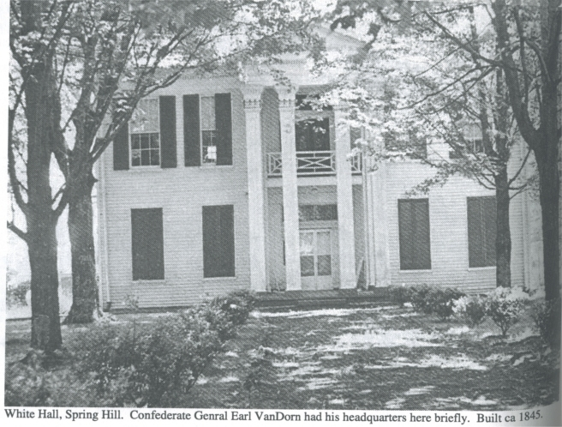
This is the old antebullem home built ca 1845 as it was photographed and in the book by Jill Garrett. A historic Civil War murder almost took place there when General Van Dorn was stationed there (story enclosed).
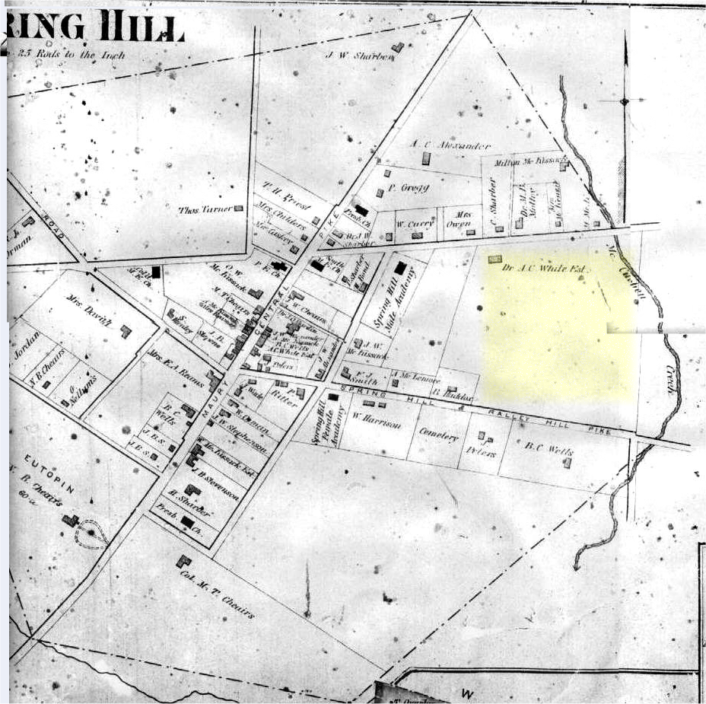
1878 Map of Spring Hill showing (highlighted in Yellow) the farm of Dr Aaron White a famous doctor during the Civil War. Sorry the map is incomplete, but all of our subject history of Spring Hill is in place.

Dr Aron White’s family listed in Spring Hill Cemetery is the next section. Forgive the cut and past quickie.
His first wife Elizabeth is interred in the Jackson College/Old Brick Church Cemetery. She died many years prior to the Civil War during 1853. That cemetery is about 2 miles southeast of his home in Spring Hill on what was then the Spring Hill Road (Pike) to Kedron another little villiage to the southeast of Spring Hill. His first wife’s tombstone is on my cemetery site at this URL.
http://freepages.genealogy.rootsweb.com/~maury/cemetery/jacksoncollege/white89.htm

His second wife Margaret J. Fain is interred in splendor by his side in the Spring Hill Cemetery.

This leads me to believe originally he or his 1st wife had connections to Jackson College as connected to that was an old Presbyterian Church. He might have gone to school there and/or met his first wife Elizabeth there.

Tombstone listings of the Dr. Aaron White family in the Spring Hill Cemetery Spring Hill Tennessee
From the book Maury County Tennessee Cemeteries by Fred Lee Hawkins.

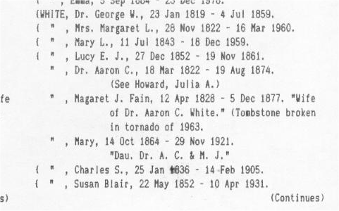

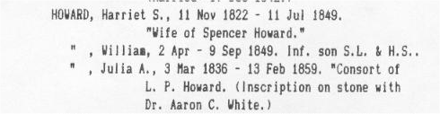
Dr White had a daughter named Julia who died in 1859 just prior to the civil War who married L. P. Howard. Dr White’s first wife Elizabeth who died in 1853 evidently was the mother the Julia above and his second wife Margaret J. must have been the mother at least of some of the above mentioned (four) children by George in the above letter.

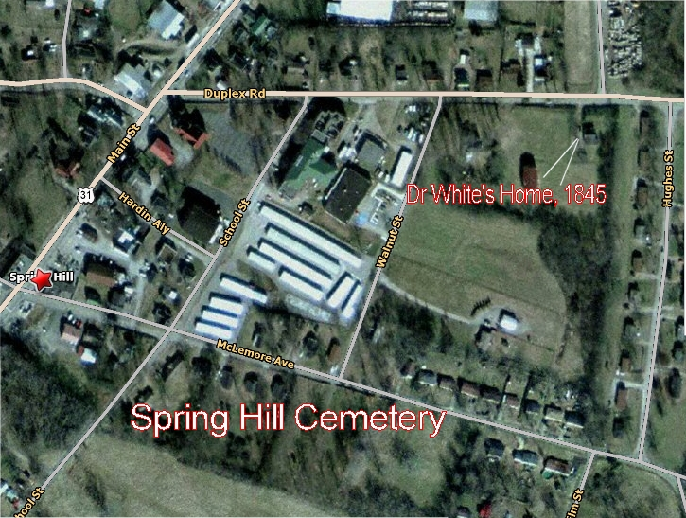
Spring Hill Aerial Map today compliments of Map Quest. I tried to place the arrows for the cemetery and home in the right place but the home might be about 1 inch to the left of where I pointed the arrow as you can see a large place there also. The cemetery is almost straight south of the Home on the 1878 map and that appears to be so here also if the home 1 inch to the left was Dr Whites Home.

Wayne Austin
Administrator
Maury County Cemeteries Web site

